CHAPTER 1
THE PROBLEM
Introduction
The increasing reliance on electrical appliances in residential settings has led to higher energy consumption and rising electricity costs worldwide. In the Philippines, residential electricity rates remain among the highest in Southeast Asia, making energy monitoring an important concern for households, tenants, and landlords. The average Filipino household consumes approximately 200–400 kilowatt-hours (kWh) per month, and electricity expenses form a significant portion of household budgets.
However, conventional power meters only provide total energy consumption and do not present detailed information regarding individual appliance usage. This limitation makes it difficult for residents—particularly tenants in boarding houses and rental units—to determine which appliances consume the most electricity and how usage can be optimized. As a result, energy awareness remains limited, and fair cost allocation becomes challenging.
Non-Intrusive Load Monitoring (NILM) offers a solution by analyzing electrical consumption patterns to identify appliance usage from aggregated energy data without requiring sensors on each device. NILM has evolved from early research into practical software-based approaches capable of classifying appliances using data analytics, pattern recognition, and machine learning techniques.
With the advancement of backend and mobile technologies, software-based NILM platforms can provide near real-time monitoring, remote access, and intelligent visualization. Centralized databases such as MySQL support scalable storage and efficient retrieval of consumption records, while mobile applications allow users to monitor usage anytime and anywhere.
This study focuses on the design and development of a software-based NILM system for residential energy monitoring. The system processes electrical parameter data obtained from existing smart meters, third-party IoT sources, or simulated datasets. The monitoring hardware and electrical data acquisition components were developed in collaboration with the Electrical Engineering team, while this study primarily concentrates on software processing, appliance classification, backend integration, and mobile application development. Through backend server processing and a cross-platform mobile application, the system enables tenants to monitor energy consumption and identify high-usage appliances, while landlords can oversee unit-level electricity usage to support fair billing and improved energy awareness.
Statement of the Problem
This study addresses the limitations of conventional residential energy monitoring by developing a software-based NILM system capable of providing appliance-level identification and real-time energy consumption insights for residential settings, particularly boarding houses and rental properties.

General Problem
How can a software-based Non-Intrusive Load Monitoring (NILM) system be designed, developed, and evaluated to provide appliance classification and real-time residential energy monitoring?

Specific Problems
- How can the system classify household appliances using aggregated energy consumption data without requiring intrusive per-appliance sensors?
- How can the system enhance tenant energy awareness through real-time visualization of instantaneous power and accumulated energy usage?
- How can the system provide landlords with a centralized platform for monitoring unit-level electricity consumption and supporting fair billing?
Conceptual Framework (IPO Model)
The study adopts the Input–Process–Output (IPO) Model as the conceptual framework in designing and developing the Software-Based Non-Intrusive Load Monitoring (NILM) System. The model explains how energy consumption datasets are collected, processed, and transformed into meaningful information for residential energy monitoring and appliance classification.
Input  - Aggregated electrical consumption datasets  - Voltage RMS  - Current RMS  - Power Factor  - Instantaneous Power  - Apparent Power (VA)  - Appliance load signature datasets  - User account information  - Tenant  - Landlord  - Internet connectivity  - System configuration settings | → | Process  - Data ingestion from datasets or IoT sources  - Data cleaning and normalization  - Calculation of electrical parameters  - Watts (W)  - Apparent Power (VA)  - Power Factor (PF)  - Energy (kWh)  - Appliance classification using load signature pattern analysis  - Centralized data storage (MySQL Database)  - Backend processing (Node.js Server / REST API)  - Real-time data synchronization  - Generation of energy summaries and role-based access | → | Output  - Real-time power monitoring (Watts)  - Accumulated energy usage (kWh)  - Identification of active appliances  - Highest energy-consuming appliance per period  - Energy usage history graphs  - Estimated electricity cost  - Tenant dashboard for personal monitoring  - Landlord dashboard showing unit-level consumption  - Alerts and notifications for high energy usage
Figure 1. Input–Process–Output Model of the Proposed Software-Based NILM System
- Input The input stage includes the data and components required for system operation, such as aggregated electrical consumption datasets (Voltage RMS, Current RMS, Power Factor, Instantaneous Power, and Apparent Power), appliance load signature datasets, user account information (Tenant and Landlord roles), Internet connectivity, and system configuration settings.
- Process The process stage involves how the system transforms input data into usable information, including data ingestion from available datasets, data filtering and normalization, calculation of electrical parameters (W, VA, PF, and kWh), appliance classification using load signature pattern analysis, data storage in the centralized MySQL database, backend processing using Node.js (REST API) services, real-time data synchronization, generation of energy consumption summaries, and role-based data access for tenants and landlords.
- Output The output stage presents the information produced by the system, such as real-time power monitoring (Watts), accumulated energy usage (kWh), identification of active appliances, highest energy-consuming appliance per period, energy usage history graphs, estimated electricity cost, landlord dashboard showing unit-level consumption, and alerts and notifications for high energy usage.

Objectives of the Study

General Objective
To design, develop, and evaluate a software-based NILM system for residential energy monitoring.

Specific Objectives
- To develop an appliance classification module using aggregated electrical consumption data (NILM load signatures).
- To design and develop a mobile application for real-time monitoring, visualization, and user dashboards.
- To evaluate the software system in terms of usability, accuracy, reliability, and performance efficiency.

Significance of the Study
Tenants – Provides awareness of personal energy consumption and helps identify high-usage appliances.
Landlords – Supports transparent monitoring and fair electricity cost allocation.
Researchers – Serves as reference for software-based NILM and IoT energy analytics.
Academic Community – Demonstrates integration of mobile development, cloud computing, and data analytics.

Scope and Limitations of the Study
This study focuses on the design, development, and evaluation of a software-based Non-Intrusive Load Monitoring (NILM) system for residential environments, particularly boarding houses and rental units. The system processes aggregated electrical consumption datasets containing parameters such as Voltage RMS, Current RMS, Instantaneous Power (W), Apparent Power (VA), Power Factor (PF), and estimated energy consumption (kWh) generated from external monitoring hardware.
The collected data are stored in a centralized MySQL database and processed through backend services developed using Node.js. A mobile application developed using React Native and Expo provides real-time monitoring, historical consumption visualization, estimated electricity cost computation, role-based dashboards, and alert notifications for tenants and landlords. The system detects appliance usage patterns and identifies unusual or prolonged electricity consumption.
The study also includes remote outlet control functionality that allows users to switch power outlets ON or OFF through the mobile application. Control commands are transmitted to the NILM monitoring device, where hardware switching components execute the outlet switching operation. Appliances connected to the controlled outlet are therefore indirectly managed. The mobile application serves as the primary interface for both monitoring and control.
However, the study is limited to residential energy consumption datasets and does not cover industrial or large-scale monitoring scenarios. Appliance identification is restricted to selected common household appliances and may not generalize across all appliance brands or models. Classification is limited to ON/OFF detection and signature-based analysis using available datasets, and computed energy values represent estimates rather than utility-grade measurements.
System accuracy may be affected by appliances with similar consumption patterns and simultaneous appliance operation. Real-time monitoring and remote control performance depend on Internet connectivity, server availability, and the operational status of the monitoring device and switching components. The electrical monitoring hardware, sensor calibration, and switching circuitry were developed in collaboration with the Electrical Engineering team and are not the primary focus of this study. Instead, the research emphasizes the software layer, including NILM processing, backend services, data analytics, and mobile application development. Finally, system evaluation is limited to the defined testing period and selected respondents.
The system may have difficulty accurately identifying or classifying individual appliances when multiple devices are connected through extension outlets or power strips. Since several appliances share a single electrical pathway, their load signatures can overlap, which reduces classification accuracy.

Definition of Terms
Appliance Classification – The process of identifying household appliances by analyzing aggregated electrical consumption patterns using the NILM system.
Apparent Power (VA) – The total electrical power combining real and reactive components used in NILM analysis.
Cloud Computing – The use of Internet-hosted services for data storage, processing, and synchronization, enabling remote access to the system.
Backend Services (Node.js) – Server-side services responsible for processing energy data, validating readings, implementing business logic, and generating system notifications.
Current RMS – The effective current value used for estimating energy consumption.
Dashboard – The user interface that displays real-time energy data, consumption summaries, alerts, and visualization graphs.
Data Visualization – The graphical presentation of energy consumption data through charts, graphs, and dashboards.
Energy Consumption (kWh) – The total amount of electrical energy used over a period of time, measured in kilowatt-hours.
MySQL Database – A relational database used to store, manage, and retrieve energy monitoring data, user information, and system logs.
Instantaneous Power (W) – The amount of electrical power consumed at a specific moment, measured in watts.
ISO/IEC 25010 – An international software quality standard used to assess system performance, usability, reliability, and other quality characteristics.
Landlord/Admin – A user role with access to summarized unit-level energy consumption reports and monitoring features.
Load Signature – The unique energy consumption pattern of an appliance used by the NILM system for identification.
Mobile Application – A cross-platform software application that provides energy monitoring, visualization, and system management features.
Non-Intrusive Load Monitoring (NILM) – A software-based method of identifying appliance usage from aggregated energy consumption data without installing sensors on individual devices.
Power Factor (PF) – A value that indicates how efficiently electrical power is being used, derived from electrical parameter data.
React Native – A software framework used to develop cross-platform mobile applications using a single codebase.
Real-Time Monitoring – The continuous display of updated energy consumption data with minimal delay.
Software-Based NILM System – A platform that processes electrical datasets, performs appliance classification, and provides visualization without requiring dedicated hardware sensors.
System Usability Scale (SUS) – A standardized tool used to evaluate the usability of the developed software system.
Tenant – A user role that allows viewing of personal or unit-level energy consumption and appliance usage insights.
Voltage RMS – The effective voltage value used by the system for power calculations.

CHAPTER 2

REVIEW OF RELATED LITERATURE AND STUDIES
This chapter presents the review of related literature and studies that establish the theoretical and empirical foundation for the development of the proposed software-based Non-Intrusive Load Monitoring (NILM) system. The review includes both local and foreign literature focusing on energy monitoring platforms, electrical load signature analysis, appliance classification techniques, data analytics, cloud-based architectures, and mobile application integration for real-time monitoring.
The chapter examines the evolution of NILM technology from its foundational principles to modern software-driven approaches that utilize signal processing, pattern recognition, and machine learning. It also discusses how cloud computing services and mobile-first architectures enhance residential energy transparency and accessibility through real-time visualization and analytics.
Furthermore, the review contextualizes the study within the Philippine residential setting, particularly in boarding houses and rental properties where energy cost allocation and consumption awareness remain significant concerns. The chapter concludes with a synthesis of reviewed literature and the identification of research gaps that justify the development of a cost-effective, mobile-integrated NILM software platform tailored to the Philippine context.

Local Literature
Energy Monitoring in the Philippines
The Philippines faces significant challenges in energy consumption management, with residential electricity rates among the highest in Southeast Asia. According to the Department of Energy (DOE), residential electricity consumption has steadily increased, with average household usage ranging from 200–400 kWh per month. The lack of detailed consumption insights limits consumers’ ability to identify energy-saving opportunities and adjust usage behavior effectively. Government agencies such as the Energy Regulatory Commission have promoted smart metering initiatives to improve energy efficiency; however, most implementations focus on aggregated consumption data rather than appliance-level insights. Consequently, the application of software-based Non-Intrusive Load Monitoring (NILM) analytics in residential environments remains limited in the Philippine context. Additionally, the Data Privacy Act of 2012 (RA 10173) requires systems handling energy consumption data to ensure proper user consent, secure storage, and controlled access. These requirements are particularly relevant for multi-tenant monitoring platforms where role-based access and data ownership must be carefully managed.
Non-Intrusive Load Monitoring (NILM) was first introduced by Hart (1992), demonstrating that individual appliance consumption could be disaggregated from aggregated household energy data without installing sensors on each device. Over time, NILM has evolved from rule-based analysis toward software-driven approaches that utilize data analytics, pattern recognition, and machine learning to improve classification accuracy (Zoha et al., 2012; Kelly & Knottenbelt, 2015). The fundamental concept of NILM is that each appliance produces a unique load signature characterized by steady-state power behavior, transient events during switching, and time-series consumption patterns. By extracting relevant features from these patterns, software algorithms can identify appliance operation from overall energy usage. Contemporary NILM approaches include rule-based classification methods, probabilistic models such as Hidden Markov Models, neural network-based learning, deep learning frameworks, and hybrid analytical techniques that combine multiple methods to enhance performance and reliability (Zoha et al., 2012; Kelly & Knottenbelt, 2015).
Recent research emphasizes dataset-based NILM implementations in which appliance identification is performed using historical consumption data rather than dedicated hardware instrumentation (Makonin et al., 2017). Through proper data preprocessing, normalization, and feature extraction, classification models can achieve improved accuracy while remaining computationally efficient (Bonfigli et al., 2018). This shift toward software-centric NILM aligns with the growing availability of smart meter datasets and cloud computing platforms that support large-scale time-series analysis (Makonin et al., 2017).
Cloud-integrated energy monitoring systems play a critical role in enabling scalable NILM deployment. Cloud computing provides flexible data storage, cross-platform accessibility, and cost-effective infrastructure for processing energy data (Hashem et al., 2015). Relational databases such as MySQL support structured storage, efficient querying, and scalable backend integration for software-based NILM platforms, allowing continuous data management and reliable retrieval of monitoring records without requiring complex infrastructure.
Mobile application integration further enhances the usability of NILM systems by serving as the primary interface between users and energy analytics. Mobile platforms provide real-time visualization of consumption data, historical usage analysis, appliance activity insights, and alert mechanisms that notify users of unusual consumption patterns. Studies indicate that mobile-first monitoring significantly improves user engagement, promotes energy awareness, and encourages behavioral changes that contribute to energy savings (Darby, 2006; Fischer, 2008; Karakose et al., 2020). As a result, the combination of NILM analytics, backend data management, and mobile application development represents a comprehensive software approach to residential energy monitoring.
Local Studies
Energy Monitoring in Philippine Residential Settings
Several studies conducted in the Philippine context highlight the importance of detailed energy monitoring and the growing demand for non-intrusive, mobile-based solutions. Dela Cruz and Santos (2020) analyzed energy consumption patterns among 500 households in Metro Manila and found that air conditioning units account for 40–50% of total consumption, refrigerators consume 15–20%, while lighting and other appliances contribute approximately 30–35%, with peak usage occurring during evening hours and average monthly consumption ranging from 200–400 kWh. Their findings emphasized the need for appliance-level monitoring to help consumers identify energy-saving opportunities. Garcia and Tan (2021) examined smart home technology adoption barriers and reported limited awareness of energy monitoring technologies, cost concerns as a major barrier, strong preference for mobile-based monitoring solutions, and the need for non-intrusive installation methods with privacy protections. Similarly, Villanueva and Ramos (2019) explored energy management challenges in multi-tenant residential buildings and found that landlords struggle with fair cost allocation while tenants lack visibility into their consumption, highlighting the need for systems that support both tenant-level and landlord-level monitoring. Bautista and Fernandez (2021) conducted a feasibility study on energy monitoring platforms in residential buildings and concluded that while monitoring technologies are technically viable, affordable and user-friendly implementations are necessary for broader adoption. Reyes and Lim (2022) identified challenges in smart meter implementation, including infrastructure limitations, consumer acceptance barriers, regulatory gaps, and interoperability issues, reinforcing the importance of non-intrusive software approaches that do not depend on utility-level infrastructure. Torres and Aquino (2020) examined energy consumption behavior in Cagayan de Oro City and reported high tenant interest in monitoring technologies, particularly in boarding house environments. In addition, Mendoza and Cruz (2021) highlighted the significance of mobile-first application development for energy monitoring, noting user preference for cross-platform mobile solutions and intuitive visualization features. Ong and Sy (2019) further emphasized the advantages of cloud-based energy data management, including scalability, cost-effectiveness, and improved accessibility, while also noting connectivity and data privacy considerations. Collectively, these studies support the development of a software-based NILM system that integrates mobile visualization, cloud data management, and role-based monitoring tailored to Philippine residential environments.
Foreign Studies
NILM System Implementations
Foundational research on Non-Intrusive Load Monitoring (NILM) began with Hart (1992), who demonstrated that individual appliance consumption could be disaggregated from aggregated household energy measurements using steady-state and transient analysis. The study achieved approximately 90% accuracy in identifying major appliances and established the theoretical basis for NILM, while also highlighting limitations in distinguishing appliances with similar power consumption characteristics (Hart, 1992). Building on this work, Kelly and Knottenbelt (2015) developed the UK-DALE dataset and applied machine learning techniques, particularly Hidden Markov Models, achieving 85–95% classification accuracy across more than 20 appliance types while enabling real-time processing and reproducible research through the NILMTK toolkit. European research by Bonfigli et al. (2018) demonstrated that residential energy monitoring systems can produce 15–20% energy savings by improving user awareness, with mobile interfaces significantly enhancing user satisfaction and engagement. More recent advances emphasize deep learning approaches, such as the bidirectional LSTM model proposed by Kaselimi et al. (2021), which achieved improved classification accuracy of up to 96% and better handling of complex appliance combinations while reducing computational requirements. Similarly, Nalmpantis and Vrakas (2020) explored time-series representations for NILM and identified effective feature extraction techniques that improve scalability and real-time performance. Beyond NILM algorithms, IoT-integrated energy monitoring research by Al-Ali et al. (2017) demonstrated that real-time monitoring combined with cloud analytics can reduce household energy consumption by 10–15% through behavioral changes and improved user engagement, particularly when mobile applications serve as the primary interface. Collectively, these studies highlight the evolution of NILM from rule-based approaches to advanced software-based analytics supported by cloud computing and mobile platforms, reinforcing the feasibility of developing scalable software-based residential energy monitoring systems.

Synthesis of Reviewed Literature and Studies
Based on the reviewed literature and studies, key themes and insights were identified.
1. Software NILM Has Become a Practical Solution
Recent studies show that NILM has evolved from theoretical research into practical software platforms capable of identifying appliance usage using aggregated energy datasets with high accuracy.
2. Cloud-Based Energy Monitoring Improves Accessibility and Scalability
Cloud computing enables real-time synchronization, scalable storage, and cross-platform access, allowing energy monitoring systems to operate efficiently without complex infrastructure.
3. Mobile-First Interfaces Enhance User Engagement
Literature consistently highlights that mobile applications providing real-time visualization, historical analytics, and alerts significantly improve energy awareness and user participation.
4. Role-Based Monitoring Is Important in Multi-Tenant Environments
Studies emphasize the need for systems that support both tenant-level and administrator-level monitoring to enable transparent reporting and fair energy cost allocation in rental properties.
5. Cost-Effective Software Solutions Support Wider Adoption
Research indicates that affordable, non-intrusive, software-driven monitoring platforms are more suitable for developing contexts where users prefer solutions that do not require complex installations.
6. Philippine Context Shows Strong Demand but Limited Implementation
Local studies reveal high interest in energy monitoring technologies, particularly in boarding houses, yet there is limited implementation of software-based NILM systems tailored to Philippine residential environments.

Research Gap
While numerous studies have explored Non-Intrusive Load Monitoring (NILM) technology and residential energy monitoring platforms, several gaps remain evident:
1. Limited NILM Implementation in the Philippine Residential Context
Most NILM research has been conducted in developed countries, resulting in limited studies that consider Philippine energy consumption patterns, cost structures, Internet connectivity conditions, and housing types such as boarding houses and rental units.
2. Few Systems Supporting Tenant–Landlord Energy Management
Existing monitoring platforms are primarily designed for single households. There is limited research on software systems that provide role-based monitoring where tenants can view individual consumption while landlords can access summarized unit-level data to support fair cost allocation.
3. Limited Mobile-First NILM Software Platforms
Although energy monitoring applications exist, many function only as dashboards rather than mobile-native NILM systems that support real-time analytics, appliance classification feedback, and cross-platform deployment.
4. Lack of Cost-Effective Cloud-Based Implementations
Many studies rely on complex infrastructure, creating a gap in research focused on affordable NILM software platforms that utilize cloud services, open-source tools, and scalable database solutions suitable for developing environments.
5. Insufficient Exploration of Real-Time Cloud Processing
There is limited research on NILM software systems that implement real-time data processing using serverless architectures, real-time synchronization, and cloud-native analytics pipelines.
6. Limited Integration of Modern Software Development Frameworks
Few studies demonstrate the combined use of modern mobile frameworks, cloud databases, and software analytics tools in a single NILM platform, highlighting the need for integrated, user-centered energy monitoring solutions.
These gaps justify the development of the proposed software-based Non-Intrusive Load Monitoring (NILM) system tailored for Philippine residential environments.

This Study’s Contribution
This research addresses the identified gaps by:
1. Developing a Philippine-Context NILM Software Platform
Designing a system tailored to residential environments, including boarding houses and rental properties.
2. Implementing Tenant–Landlord Monitoring Features
Providing role-based dashboards that support both individual consumption visibility and administrative reporting.
3. Adopting a Mobile-First Architecture
Creating a mobile-native NILM application that enables real-time visualization, analytics, and user interaction across platforms.
4. Utilizing Cost-Effective Cloud Technologies
Leveraging cloud databases, serverless processing, and open-source tools to create a scalable and affordable monitoring platform.
5. Enabling Real-Time Cloud Integration
Supporting continuous synchronization, automated analytics, and remote monitoring through cloud-based services.
6. Demonstrating an Integrated Software Technology Stack
Combining mobile development frameworks, cloud data management, and NILM analytics to provide a comprehensive residential energy monitoring solution.

References
Foreign Literature
1. Hart, G. W. (1992). Nonintrusive appliance load monitoring. Proceedings of the IEEE, 80(12), 1870-1891. https://doi.org/10.1109/5.192069
2. Zeifman, M., & Roth, K. (2011). Nonintrusive appliance load monitoring: Review and outlook. IEEE Transactions on Consumer Electronics, 57(1), 76-84. https://doi.org/10.1109/TCE.2011.5735484
3. Bonfigli, R., Principi, E., Fagiani, M., Severini, M., Squartini, S., & Piazza, F. (2018). Non-intrusive load monitoring by using active and reactive power in additive factorial hidden Markov models. Applied Energy, 208, 1590-1607. https://doi.org/10.1016/j.apenergy.2017.08.242
4. Kelly, J., & Knottenbelt, W. (2015). The UK-DALE dataset, domestic appliance-level electricity demand and whole-house demand from five UK homes. Scientific Data, 2, 150007. https://doi.org/10.1038/sdata.2015.7
5. Kolter, J. Z., & Johnson, M. J. (2011). REDD: A public data set for energy disaggregation research. Proceedings of the SustKDD Workshop on Data Mining Applications in Sustainability, 1-6.
6. Makonin, S., Popowich, F., Bajić, I. V., Gill, B., & Bartram, L. (2016). Exploiting HMM sparsity to perform online real-time nonintrusive load monitoring. IEEE Transactions on Smart Grid, 7(6), 2575-2584. https://doi.org/10.1109/TSG.2015.2494592
7. Batra, N., Kelly, J., Parson, O., Dutta, H., Knottenbelt, W., Rogers, A., ... & Whitehouse, K. (2014). NILMTK: An open source toolkit for non-intrusive load monitoring. Proceedings of the 5th International Conference on Future Energy Systems, 265-276. https://doi.org/10.1145/2602044.2602051
8. Kim, H., Marwah, M., Arlitt, M., Lyon, G., & Han, J. (2011). Unsupervised disaggregation of low frequency power measurements. Proceedings of the 11th SIAM International Conference on Data Mining, 747-758. https://doi.org/10.1137/1.9781611972818.64
9. Parson, O., Ghosh, S., Weal, M., & Rogers, A. (2012). Non-intrusive load monitoring using prior models of general appliance types. Proceedings of the 26th AAAI Conference on Artificial Intelligence, 356-362.
10. Zoha, A., Gluhak, A., Imran, M. A., & Rajasegarar, S. (2012). Non-intrusive load monitoring approaches for disaggregated energy sensing: A survey. Sensors, 12(12), 16838-16866. https://doi.org/10.3390/s121216838

IoT and Cloud-Based Energy Monitoring
11. Al-Ali, A. R., Zualkernan, I. A., Rashid, M., Gupta, R., & Alikarar, M. (2017). A smart home energy management system using IoT and big data analytics approach. IEEE Transactions on Consumer Electronics, 63(4), 426-434. https://doi.org/10.1109/TCE.2017.015014
12. Gungor, V. C., Sahin, D., Kocak, T., Ergut, S., Buccella, C., Cecati, C., & Hancke, G. P. (2011). Smart grid technologies: Communication technologies and standards. IEEE Transactions on Industrial Informatics, 7(4), 529-539. https://doi.org/10.1109/TII.2011.2166794
13. Stojkoska, B. L. R., & Trivodaliev, K. V. (2017). A review of Internet of Things for smart home: Challenges and solutions. Journal of Cleaner Production, 140, 1454-1464. https://doi.org/10.1016/j.jclepro.2016.10.006
14. Al-Fuqaha, A., Guizani, M., Mohammadi, M., Aledhari, M., & Ayyash, M. (2015). Internet of Things: A survey on enabling technologies, protocols, and applications. IEEE Communications Surveys & Tutorials, 17(4), 2347-2376. https://doi.org/10.1109/COMST.2015.2444095
15. Zanella, A., Bui, N., Castellani, A., Vangelista, L., & Zorzi, M. (2014). Internet of Things for smart cities. IEEE Internet of Things Journal, 1(1), 22-32. https://doi.org/10.1109/JIOT.2014.2306328
Mobile Applications for Energy Monitoring
16. Froehlich, J., Findlater, L., & Landay, J. (2010). The design of eco-feedback technology. Proceedings of the SIGCHI Conference on Human Factors in Computing Systems, 1999-2008. https://doi.org/10.1145/1753326.1753629
17. Pierce, J., Schiano, D. J., & Paulos, E. (2010). Home, habits, and energy: Examining domestic interactions and energy consumption. Proceedings of the SIGCHI Conference on Human Factors in Computing Systems, 1985-1994. https://doi.org/10.1145/1753326.1753628
18. Costanza, E., Ramchurn, S. D., & Jennings, N. R. (2012). Understanding domestic energy consumption through interactive visualisation: A field study. Proceedings of the 2012 ACM Conference on Ubiquitous Computing, 216-225. https://doi.org/10.1145/2370216.2370252
Recent NILM Studies (2020-2024)
19. Kaselimi, M., Protopapadakis, E., Voulodimos, A., Doulamis, N., & Doulamis, A. (2021). Bayesian-optimized bidirectional LSTM regression model for non-intrusive load monitoring. IEEE Transactions on Industrial Informatics, 17(11), 7633-7643. https://doi.org/10.1109/TII.2021.3058872
20. Nalmpantis, C., & Vrakas, D. (2020). On time series representations for deep learning-based energy disaggregation. IEEE Transactions on Smart Grid, 11(6), 4994-5004. https://doi.org/10.1109/TSG.2020.2992000
21. Rafiq, H., Zhang, H., Li, H., & Ochani, M. K. (2021). Regularized LSTM based deep learning model for household energy consumption disaggregation. IEEE Access, 9, 61444-61454. https://doi.org/10.1109/ACCESS.2021.3074000
22. Shin, C., Rho, S., Lee, H., & Rhee, W. (2020). Data requirements for applying machine learning to energy disaggregation. Energies, 13(9), 2144. https://doi.org/10.3390/en13092144
Philippine Context and Local Studies
23. Department of Energy, Philippines. (2023). Philippine Energy Statistics 2022. Retrieved from https://www.doe.gov.ph/energy-statistics
24. Department of Energy, Philippines. (2022). National Energy Efficiency and Conservation Plan 2020-2040. Philippines: DOE.
25. Energy Regulatory Commission. (2022). Distribution Utilities Performance Report 2021. Philippines: ERC.
26. Energy Regulatory Commission. (2023). Smart Metering Guidelines and Implementation Framework. Philippines: ERC.
27. Philippine Statistics Authority. (2023). Household Energy Consumption Survey 2022. Retrieved from https://psa.gov.ph
28. Philippine Statistics Authority. (2022). Family Income and Expenditure Survey 2021: Energy Expenditure Analysis. Philippines: PSA.
29. Dela Cruz, R. M., & Santos, J. A. (2020). Energy consumption patterns in Metro Manila residential households: Implications for smart grid implementation. Philippine Engineering Journal, 41(2), 45-62.
30. Garcia, M. L., & Tan, K. B. (2021). Adoption barriers of smart home technologies in Philippine urban areas. Journal of Philippine Technology and Innovation, 8(3), 112-128.
31. Villanueva, A. C., & Ramos, E. P. (2019). Energy management systems for multi-tenant residential buildings in the Philippines. ASEAN Engineering Journal, 7(1), 23-35.
32. Bautista, C. D., & Fernandez, L. R. (2021). IoT-based energy monitoring system for Philippine residential buildings: A feasibility study. DLSU Research Congress 2021 Proceedings, 1-8.
33. Reyes, M. P., & Lim, A. S. (2022). Smart meter implementation challenges in Philippine distribution utilities. Philippine Journal of Electrical Engineering, 15(1), 34-48.
34. Torres, J. M., & Aquino, R. C. (2020). Energy consumption behavior of Filipino households: A case study in Cagayan de Oro City. Mindanao Journal of Science and Technology, 12(2), 67-82.
35. Mendoza, A. B., & Cruz, E. F. (2021). Mobile application development for energy monitoring: A Philippine perspective. Philippine Computing Journal, 14(3), 89-104.
This reference list follows APA 7th edition format. Adjust according to your institution's requirements (IEEE, MLA, etc.). All references are from peer-reviewed journals, conference proceedings, or official government sources. For web sources, include access dates and ensure URLs are current.

CHAPTER 3
METHODOLOGY
Research Design
This study used descriptive–evaluative methods in a developmental research design. The study focused on the design, development, and evaluation of a software-based Non-Intrusive Load Monitoring (NILM) platform, particularly the mobile application and backend server services. The system utilized electrical data generated from external monitoring hardware developed in collaboration with the Department of Electrical Engineering, while the primary scope of the study remained on software processing, data management, and visualization features.
The descriptive–evaluative method was used to assess the system’s usability, accuracy, reliability, and performance efficiency through user and expert evaluation using recognized assessment instruments. Performance evaluations and accuracy tests were treated as part of system validation and assessment rather than experimental manipulation. Therefore, the study did not apply an experimental research design; instead, it emphasized the development of a functional software prototype and the evaluation of its effectiveness and quality using standardized evaluation tools.

Respondents and Sampling Technique
Purposive sampling was used to choose the study's respondents because they had traits that were pertinent to residential energy monitoring and system assessment. The following respondent groups participated in the study:
1. Tenants (Primary Users)
A total of thirty-five (35) tenants from selected boarding houses and rental units in Cagayan de Oro City served as primary users of the system. Participants were required to:
- regularly use household appliances;
- own an Android or iOS smartphone; and
- be willing to use and evaluate the system for at least four (4) weeks.
2. Landlords / Administrators
A total of seven (7) landlords/administrators participated in evaluating the landlord monitoring features. Participants were required to:
- manage at least three (3) rental units; and
- be willing to assess unit-level monitoring and reporting features.
3. Technical Evaluators
A total of eight (8) technical experts composed of Information Technology professionals and Electrical Engineers evaluated the system’s technical quality and performance. They were selected based on experience in at least one of the following:
- IoT systems and embedded development;
- software and mobile application development; or
- energy monitoring and electrical measurement systems.
Research Locale
The study was conducted in selected boarding houses and rental properties in Cagayan de Oro City, Philippines. The locale was chosen due to the high population of student tenants, the dense concentration of rental housing, and the increasing demand for transparent energy monitoring systems in urban residential environments. According to the Philippine Statistics Authority, urban areas such as Cagayan de Oro City have experienced continuous population growth and expansion of rental housing to accommodate students and working residents (Philippine Statistics Authority, 2020). All participating sites utilized standard residential electrical systems (220V, single-phase) and had stable internet connectivity to support real-time data synchronization and cloud-based monitoring.

Data Gathering Procedure
The data gathering procedure was conducted systematically to ensure the accuracy, reliability, and validity of the collected data for the development and evaluation of the Non-Intrusive Load Monitoring (NILM) system. The following steps were undertaken:
- Permission and Coordination – Formal permission was secured from selected landlords and boarding house administrators in Cagayan de Oro City to install and test the NILM prototype in designated residential units. Participants were informed about the purpose of the study, and written consent was obtained prior to data collection.
- Requirements Gathering – Interviews, surveys, and informal consultations were conducted with tenants and landlords to identify existing energy monitoring challenges, billing concerns, and desired system features. This phase helped define both functional and non-functional requirements of the system.
- Electrical Data Collection – Electrical signals, including Voltage RMS and Current RMS, were collected using sensors connected to the ESP32 microcontroller. The system recorded real-time measurements such as Instantaneous Power (W), Apparent Power (VA), Power Factor (PF), and estimated Energy Consumption (kWh). The study primarily focused on the software processing and visualization of the collected electrical parameters, while the external hardware served only as the data acquisition source.

- System Development and Integration – The gathered requirements and collected electrical parameters served as the basis for developing the mobile application and backend integration using Node.js and MySQL.
- System Testing and Validation – The developed system underwent functional testing, integration testing, and appliance classification accuracy validation. Appliance identification results were compared with actual appliance usage to assess system performance.
- System Evaluation – The system was evaluated by tenants, landlords, and technical experts using the System Usability Scale (SUS) and ISO/IEC 25010 software quality criteria to assess usability, reliability, performance efficiency, and overall system quality.
- Data Compilation and Statistical Analysis – The evaluation results were collected, tabulated, and analyzed using appropriate statistical tools to determine overall system effectiveness, user satisfaction level, and technical performance metrics.

Research Instruments
The study used the following instruments to collect data and evaluate the system:
- System Requirements Questionnaire – gathered user expectations, existing practices, and preferred features.
- System Usability Scale (SUS) – measured perceived usability and user satisfaction.
- ISO/IEC 25010 Evaluation Checklist – assessed software quality (functional suitability, reliability, usability, performance efficiency, security, maintainability).
- Accuracy Testing Protocol – compared appliance classification results with actual appliance usage.
- Technical Performance Evaluation Form – assessed response time, synchronization speed, and system stability.
- User Interview Guide – collected qualitative feedback and improvement suggestions.
- System Logs and Analytics – recorded transmission success rates, latency, and error frequency.

System Development Life Cycle (SDLC)
The study adopted the Modified Waterfall Model, a structured and sequential development process suitable for projects with defined software requirements and clear development phases.
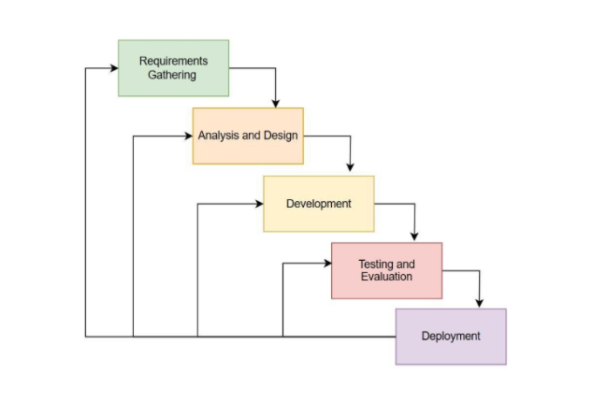
Figure 3.1 Modified Waterfall Model of SDLC
Modified Waterfall Model
This study adopted the Modified Waterfall Model in developing the software-based Non-Intrusive Load Monitoring (NILM) system. The model was selected because the project follows structured software development phases including requirements analysis, system design, application development, testing, deployment, and evaluation.
The system processes electrical consumption datasets generated from external monitoring devices developed in collaboration with the Department of Electrical Engineering. While hardware components provide data input, the primary focus of this study is on software processing, appliance classification, cloud integration, and mobile application visualization.
Although the model follows a sequential approach, limited feedback and refinement between phases were allowed, such as adjustments to data processing logic, classification algorithms, and user interface design. This approach ensures systematic development while supporting iterative software improvements.

Planning Phase
Defined the project scope, objectives, stakeholders, constraints, and success criteria. Activities included initial literature review, stakeholder consultations, selection of technology stack, risk assessment, and scheduling.

Requirements Gathering Phase
Collected user requirements through surveys and interviews. Functional and non-functional requirements were identified, including real-time monitoring, appliance classification, mobile accessibility, accuracy, security, and performance expectations.

Analysis and Design Phase

The Analysis and Design Phase involved translating the gathered requirements into structured system models and software architecture for the proposed Non-Intrusive Load Monitoring (NILM) system. This phase ensured that the software components were clearly defined before development.

The phase included the following:

● Conceptual Design – Developed context-level diagrams illustrating the interaction between tenants, landlords, external monitoring devices, and the NILM software system. This showed how electrical consumption data flows into the software for processing and visualization.

● Use Case Diagrams – Illustrated key system operations such as user registration, real-time energy monitoring, appliance classification visualization, report generation, and role-based access control for tenants and landlords.

● Database Design – Created database models defining data structures for user accounts, energy consumption records, appliance events, and system logs. Logical schema design ensured organized storage and efficient retrieval of monitoring data.

● Interface Design – Designed mobile application layouts, dashboards, and visualization components to provide clear and user-friendly presentation of real-time energy usage and appliance insights.

● Process Flowcharts – Mapped existing manual energy monitoring practices and the proposed automated workflow to illustrate improvements in data processing, reporting, and accessibility.

This phase provided the foundation for developing a scalable, maintainable, and user-centered NILM software system.

Development Phase

This phase involved the actual construction and integration of the proposed Software-Based Non-Intrusive Load Monitoring (NILM) System based on the finalized system requirements and design specifications. The software development process utilized electrical parameter data obtained from external monitoring devices developed in collaboration with the Department of Electrical Engineering. While the hardware components served as the data acquisition source, the primary focus of the study remained on software processing, cloud integration, and mobile application visualization.
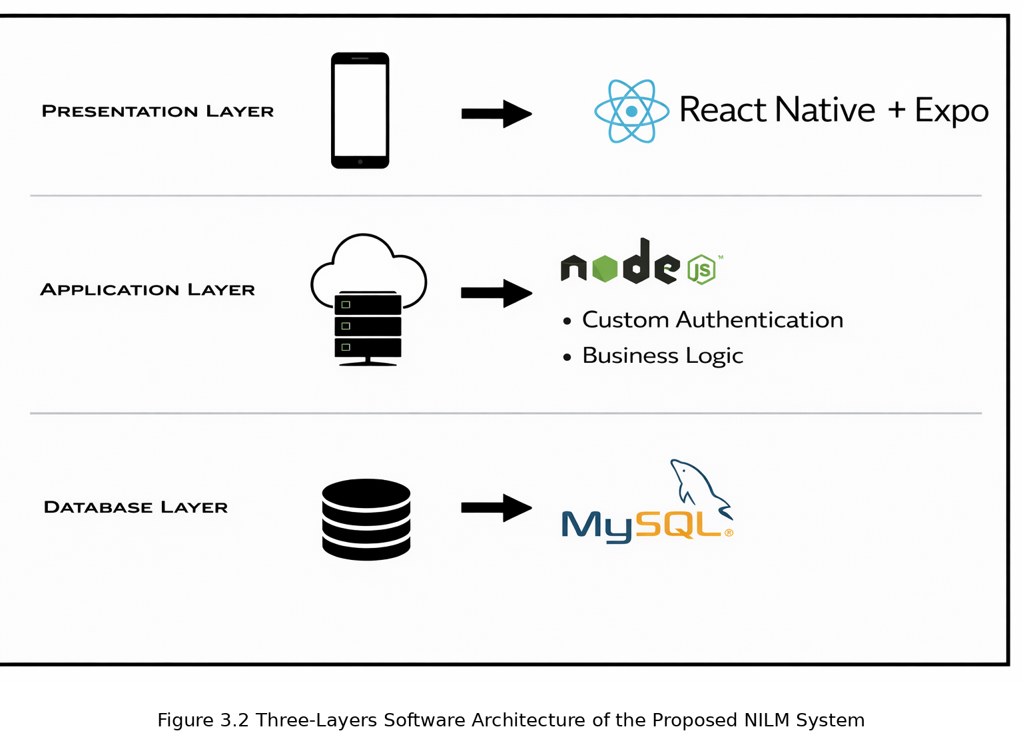

The system adopted a three-layer architecture composed of the presentation layer, application layer, and database layer.

Presentation Layer The presentation layer consists of a cross-platform mobile application developed using React Native + Expo. This layer handles user interaction, data visualization, real-time monitoring dashboards, and role-based access for tenants and landlords.

Application Layer The application layer implements backend services using Node.js, which manages custom authentication and core business logic. This includes processing of energy data, validation of incoming readings, generation of summaries, and execution of rule-based conditions for alerts and notifications.

Database Layer The database layer uses MySQL for structured storage and retrieval of system records. This layer stores user accounts, unit-level monitoring data, appliance activity logs, and historical consumption reports to support real-time monitoring and analytics.

All components were integrated to enable seamless data processing, secure authentication, and efficient retrieval of monitoring data for both tenant and landlord dashboards.

Testing and Evaluation Phase
System testing and evaluation were conducted to ensure that the developed software-based Non-Intrusive Load Monitoring (NILM) system functioned accurately, reliably, and according to the defined requirements. This phase focused on validating the software processing, real-time monitoring features, cloud synchronization, and overall usability of the system.
System testing included:
● Functionality Testing – Verified that core software features operated correctly, including user authentication, real-time energy monitoring dashboards, appliance classification visualization, and report generation.
● Integration Testing – Ensured successful mobile application, Node.js backend server, and MySQL database, and external monitoring devices providing electrical consumption data.
● Scenario-Based Testing – Simulated tenant and landlord interactions such as incorrect login attempts, missing data entries, delayed synchronization, and appliance detection events to evaluate system behavior under different conditions.
● Evaluation – Conducted with selected respondents using ISO/IEC 25010 and the System Usability Scale (SUS) to assess software quality, usability, reliability, performance efficiency, and security.
● Reliability Testing – Statistical measures such as Cronbach’s Alpha were used to verify the internal consistency of survey responses and ensure reliability of evaluation results.
Baseline comparison between existing manual electricity monitoring practices and the developed NILM software measured improvements in data accessibility, monitoring accuracy, transparency, and user experience.

Deployment Phase
After successful testing and evaluation, the developed software-based Non-Intrusive Load Monitoring (NILM) system was prepared for deployment in selected residential units. The deployment phase involved configuring the mobile application, cloud database, and user access settings to support real-time energy monitoring.
The software platform was connected to external monitoring devices that provided electrical consumption data, enabling seamless synchronization between data acquisition and system visualization. Tenants were oriented on how to use the mobile application to monitor real-time energy usage, view appliance insights, and access consumption reports. Landlords were guided on accessing unit-level summaries and monitoring dashboards.
Deployment ensured that the NILM software operated in a real-world environment, providing improved visibility of electricity consumption, enhanced reporting capabilities, and accessible monitoring features for both tenants and administrators. This phase confirmed the system’s readiness for practical use and long-term implementation.

Tools, Technologies, and Technical Environment
The development of the proposed software-based Non-Intrusive Load Monitoring (NILM) system utilized various tools, technologies, and technical platforms to support mobile application development, backend integration, and real-time data visualization.
● Programming Languages: JavaScript, TypeScript
Used for mobile application development and backend server logic.
● Frameworks/Libraries: React Native, Expo
Enabled cross-platform mobile application development with responsive user interfaces and real-time monitoring dashboards.
● Backend Platform: Node.js
Provided API development, server-side business logic, data validation, and processing of energy monitoring records.
● Database: MySQL
Used for structured storage and retrieval of user accounts, unit-level monitoring data, appliance activity logs, and historical energy consumption records.
● Authentication: Custom Authentication
Implemented role-based access control for tenants and landlords to ensure secure system access and data privacy.
● Development Tools: Visual Studio Code, GitHub
Used for coding, version control, collaboration, and project management.
● Operating System: Windows 10
Served as the primary development environment for building and testing the application.
● Mobile Platform: Android and iOS
Supported deployment of the NILM mobile application for tenants and landlords.
● Web Browser: Google Chrome
Used for system testing, API monitoring, and backend configuration. These tools were selected due to their compatibility, scalability, availability, and suitability for developing a backend-integrated mobile monitoring software system.

Ethical Considerations
The study adhered to the provisions of the Data Privacy Act of 2012 (RA 10173) to ensure the protection of participant information throughout the development and evaluation of the software-based Non-Intrusive Load Monitoring (NILM) system. Informed consent was obtained from all participants, and they were informed of the study’s purpose, procedures, and intended use of collected data.
Data collection and handling followed the principles of confidentiality, data minimization, and secure storage. Only information necessary for system functionality and evaluation was collected. The system implemented role-based access control (RBAC) to restrict data visibility according to user roles and prevent unauthorized access.
Security measures, including authentication, controlled cloud database access, and system activity logging, were applied to maintain data integrity and accountability. Participants were given the right to withdraw at any time, and all collected information was handled in accordance with established ethical research standards.

Appendix A
Appendix A: Mockup Design
Login page
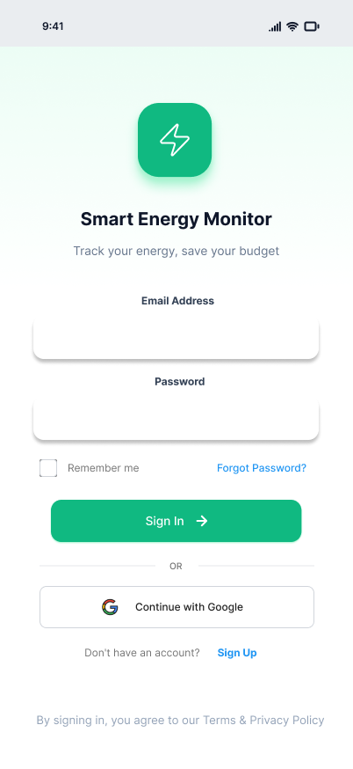

Home page (tenants)
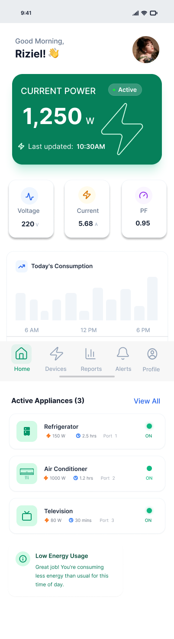
Home page (landlord)
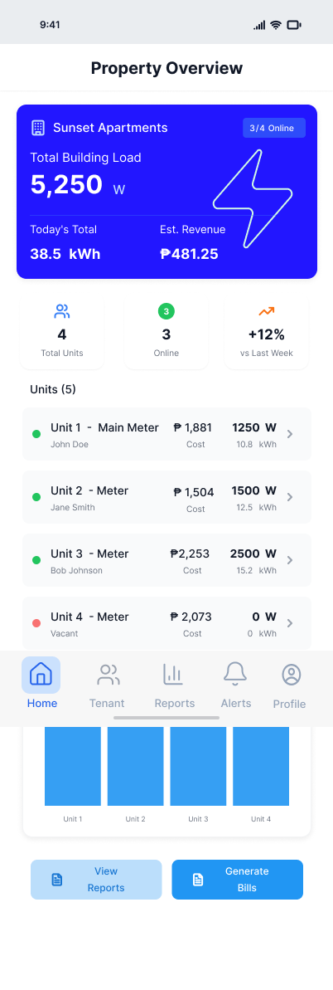

Appendix B: Letter of Intent
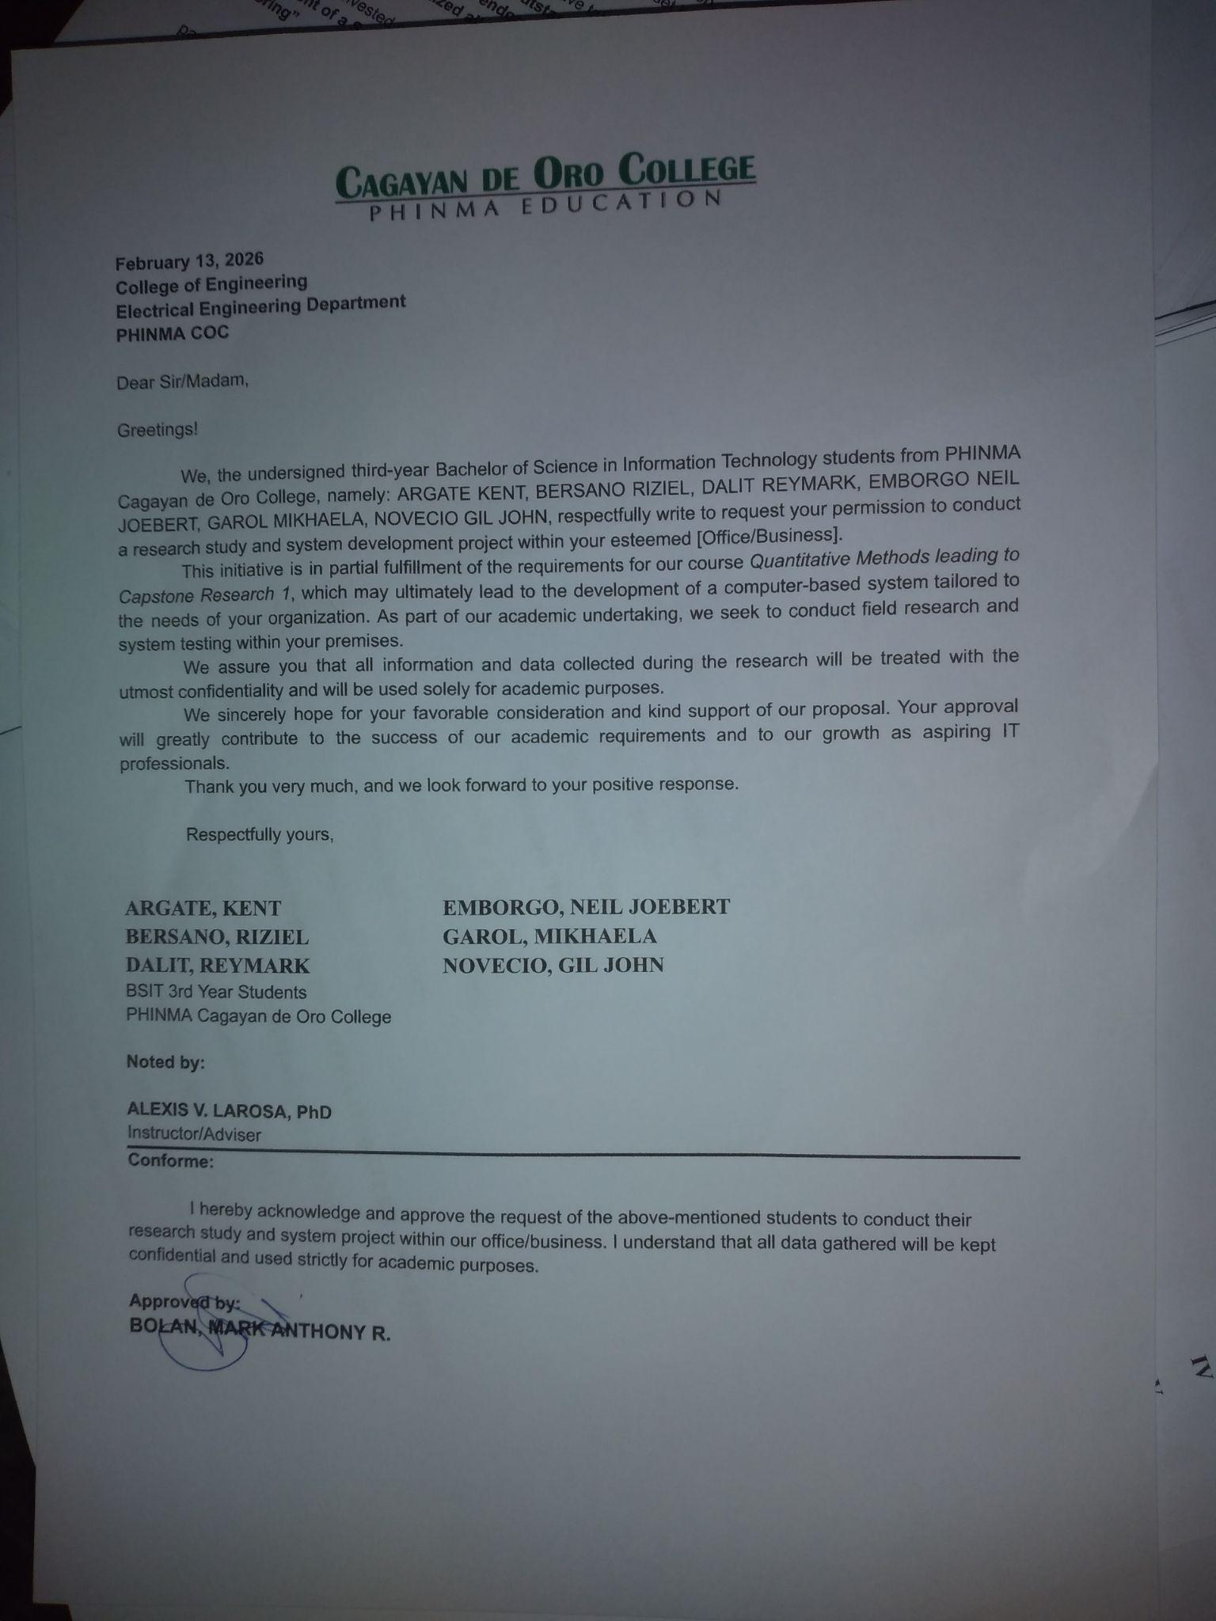

Appendix C: Gantt Chart of Activities
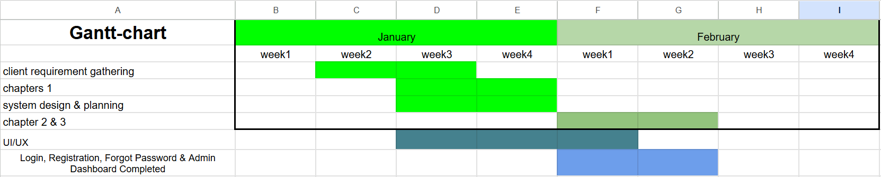

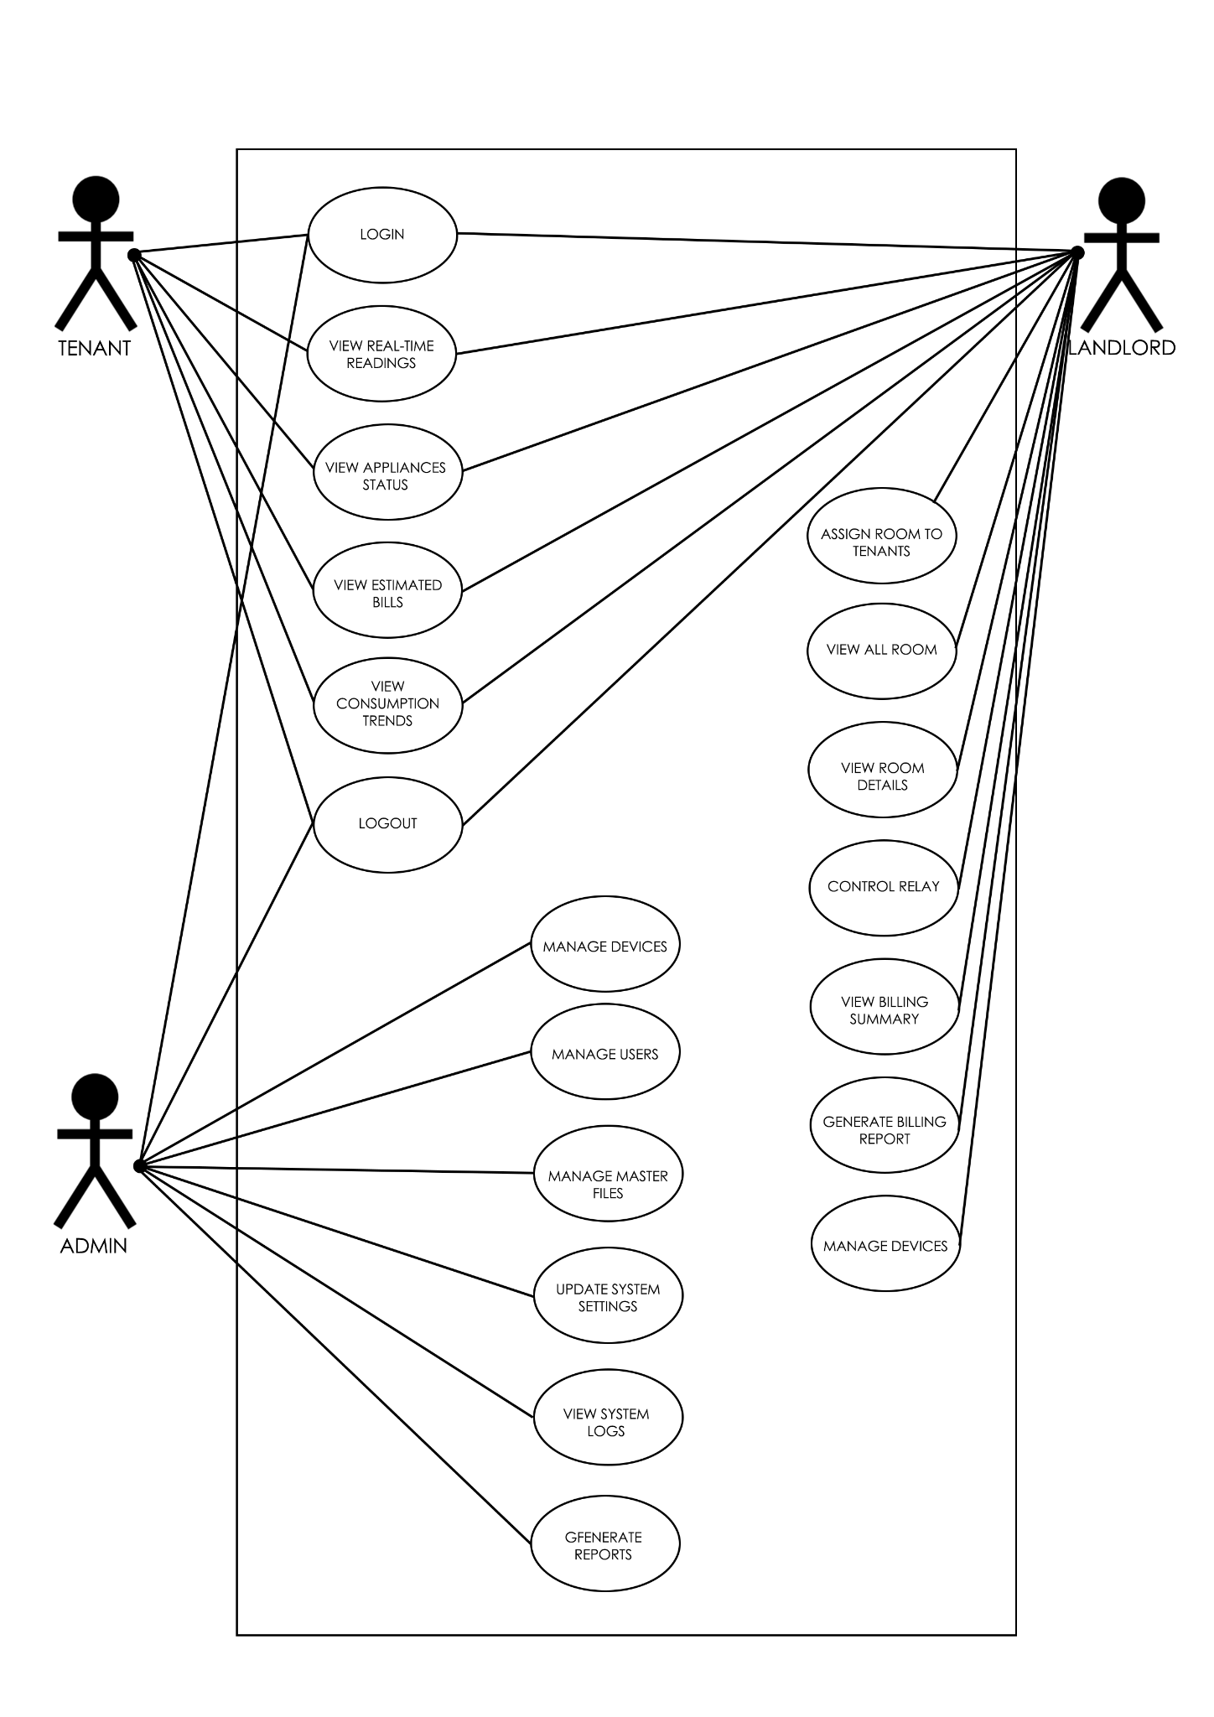
Appendix D: Use Case Diagram

Appendix E: Logical Entity Relationship Diagram (ERD)
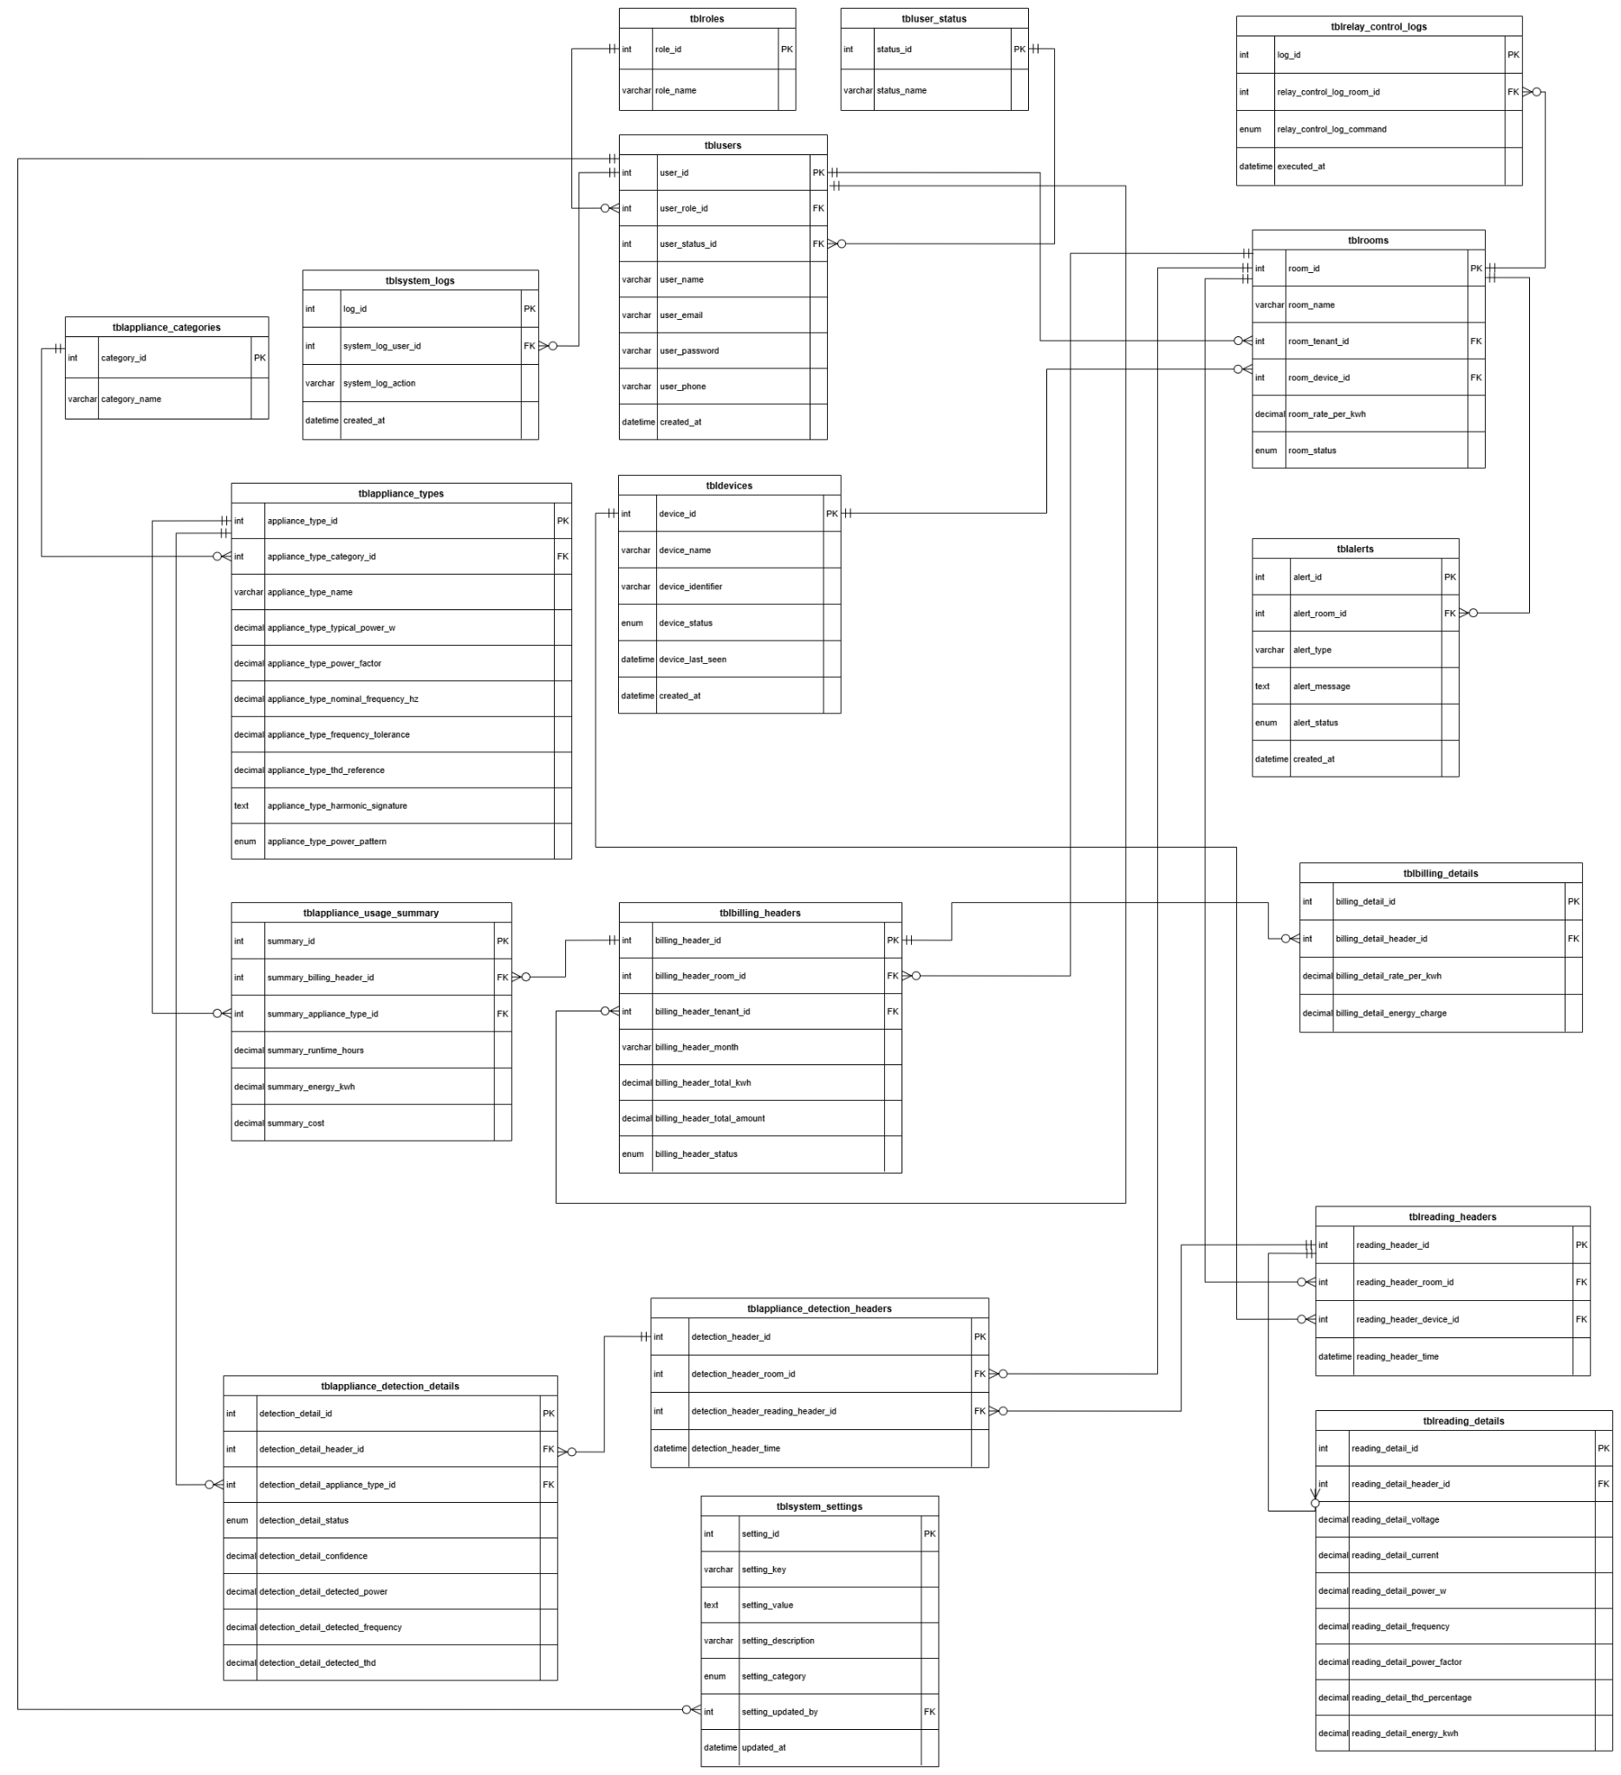

Appendix F: Data Flow Diagram
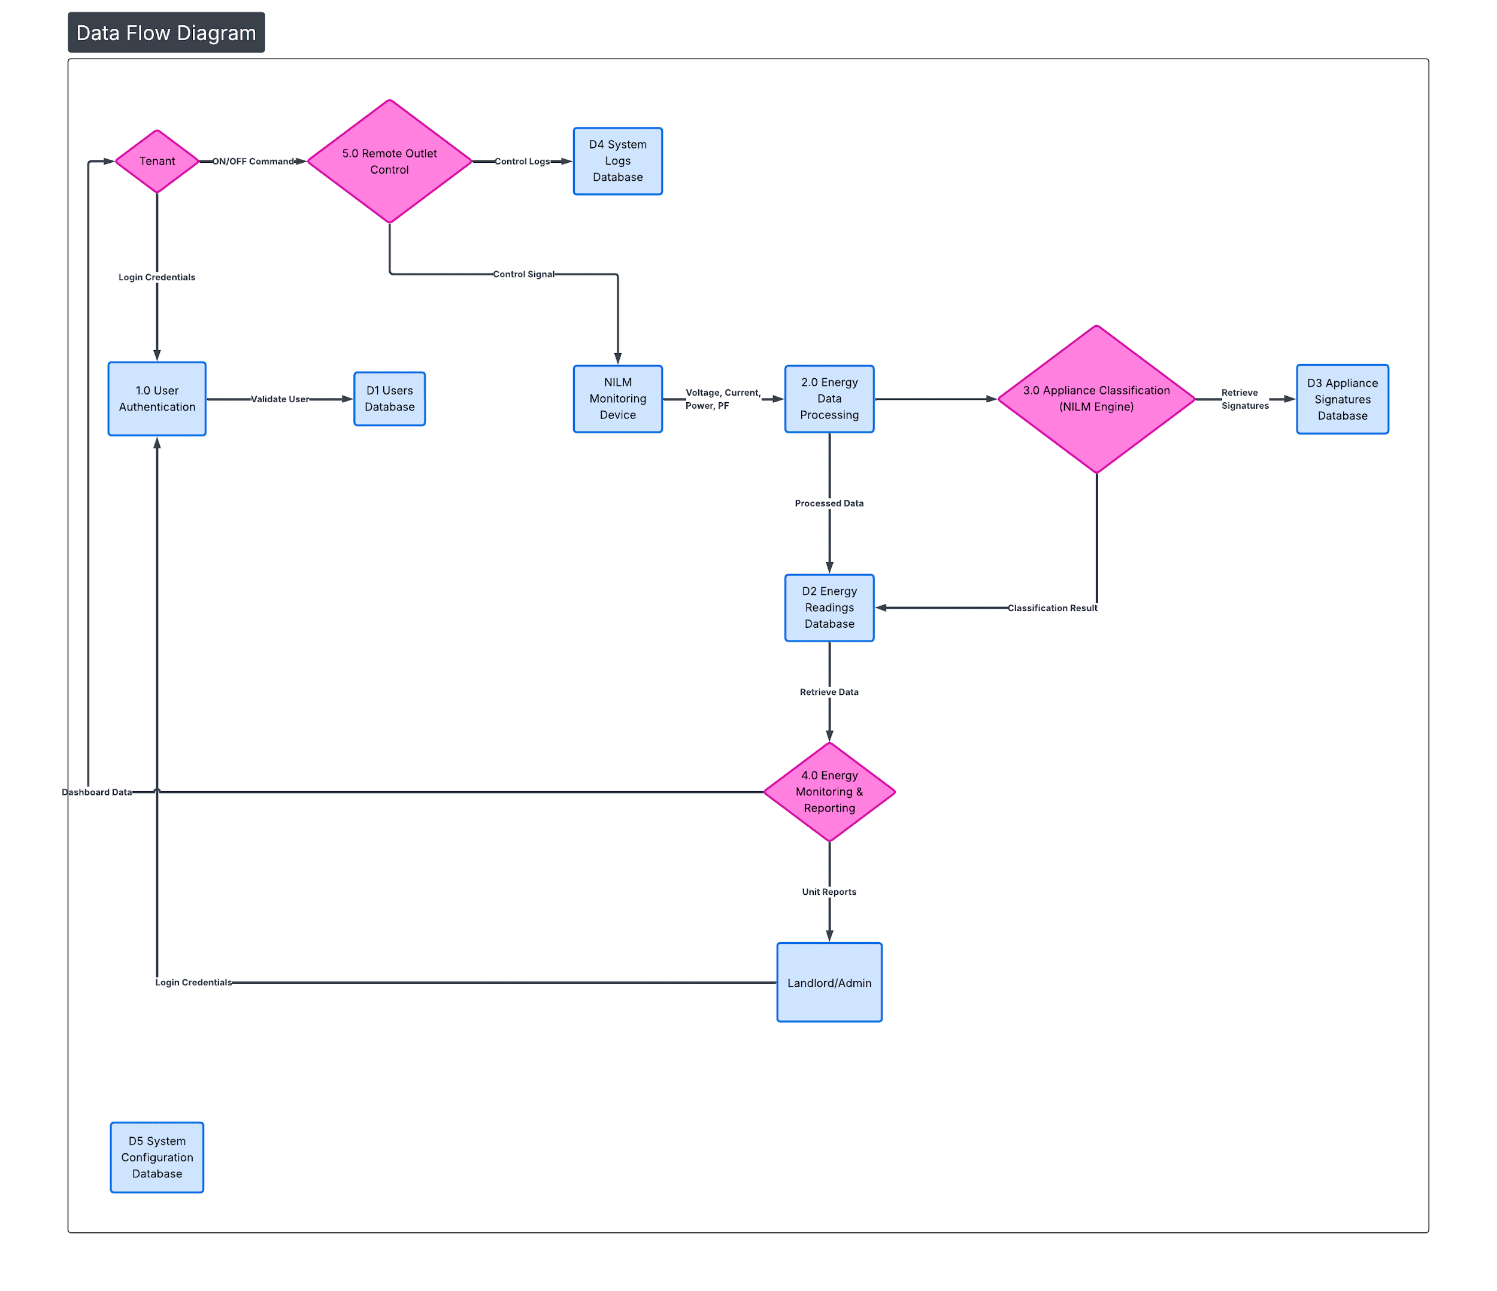

Appendix G: Context Diagram
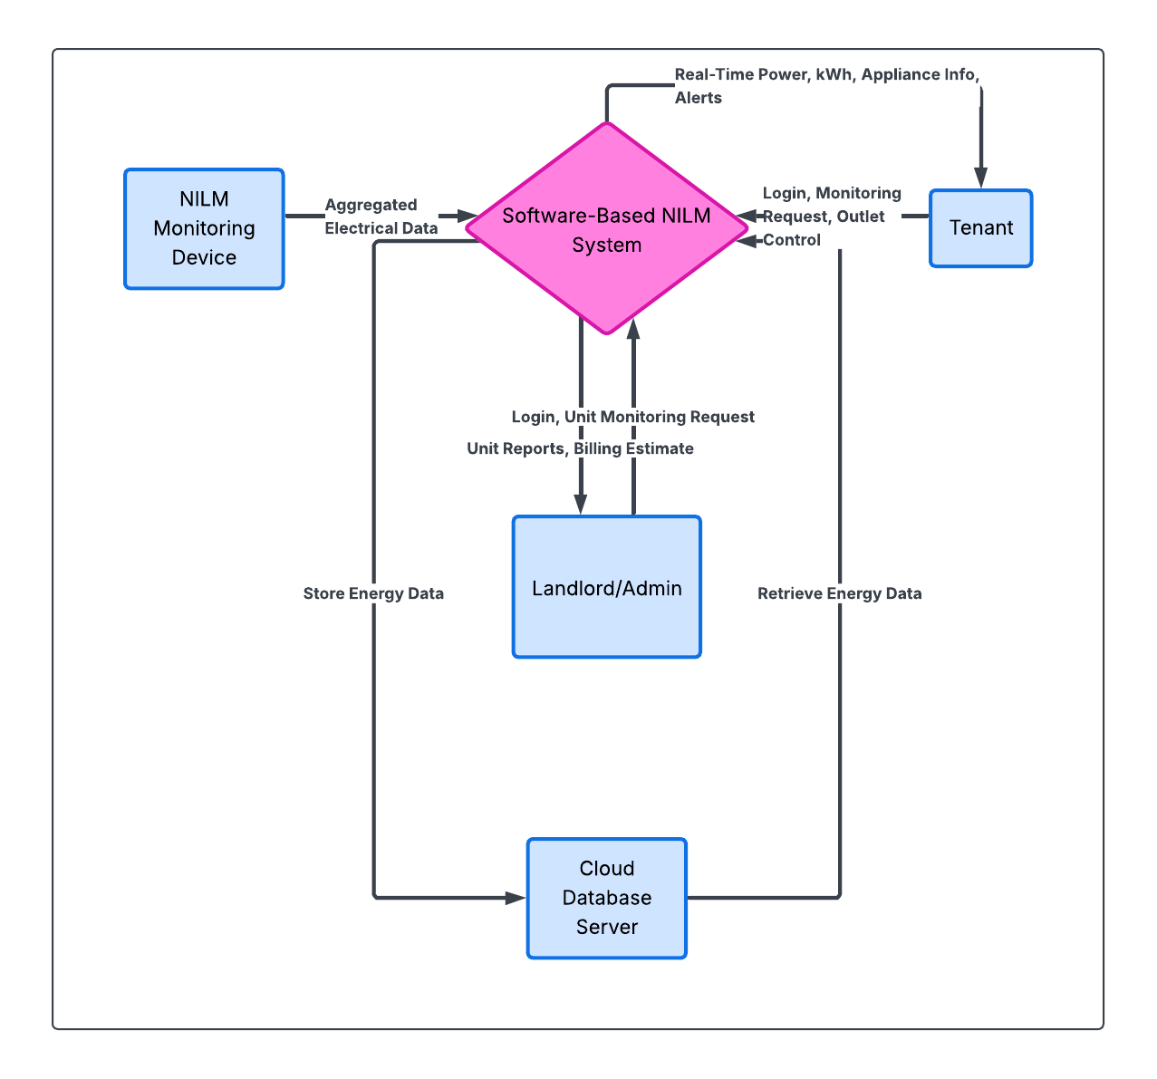

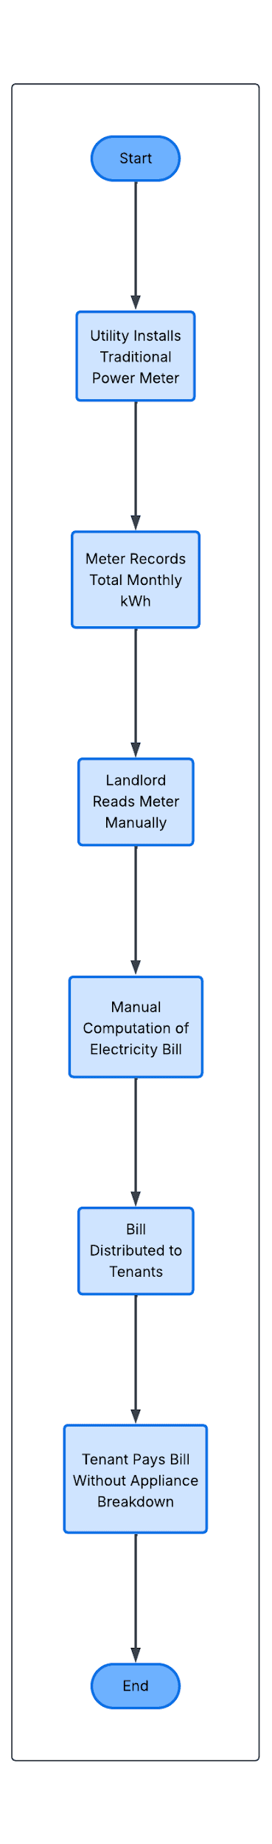
Appendix H: Manual Process Flowchart

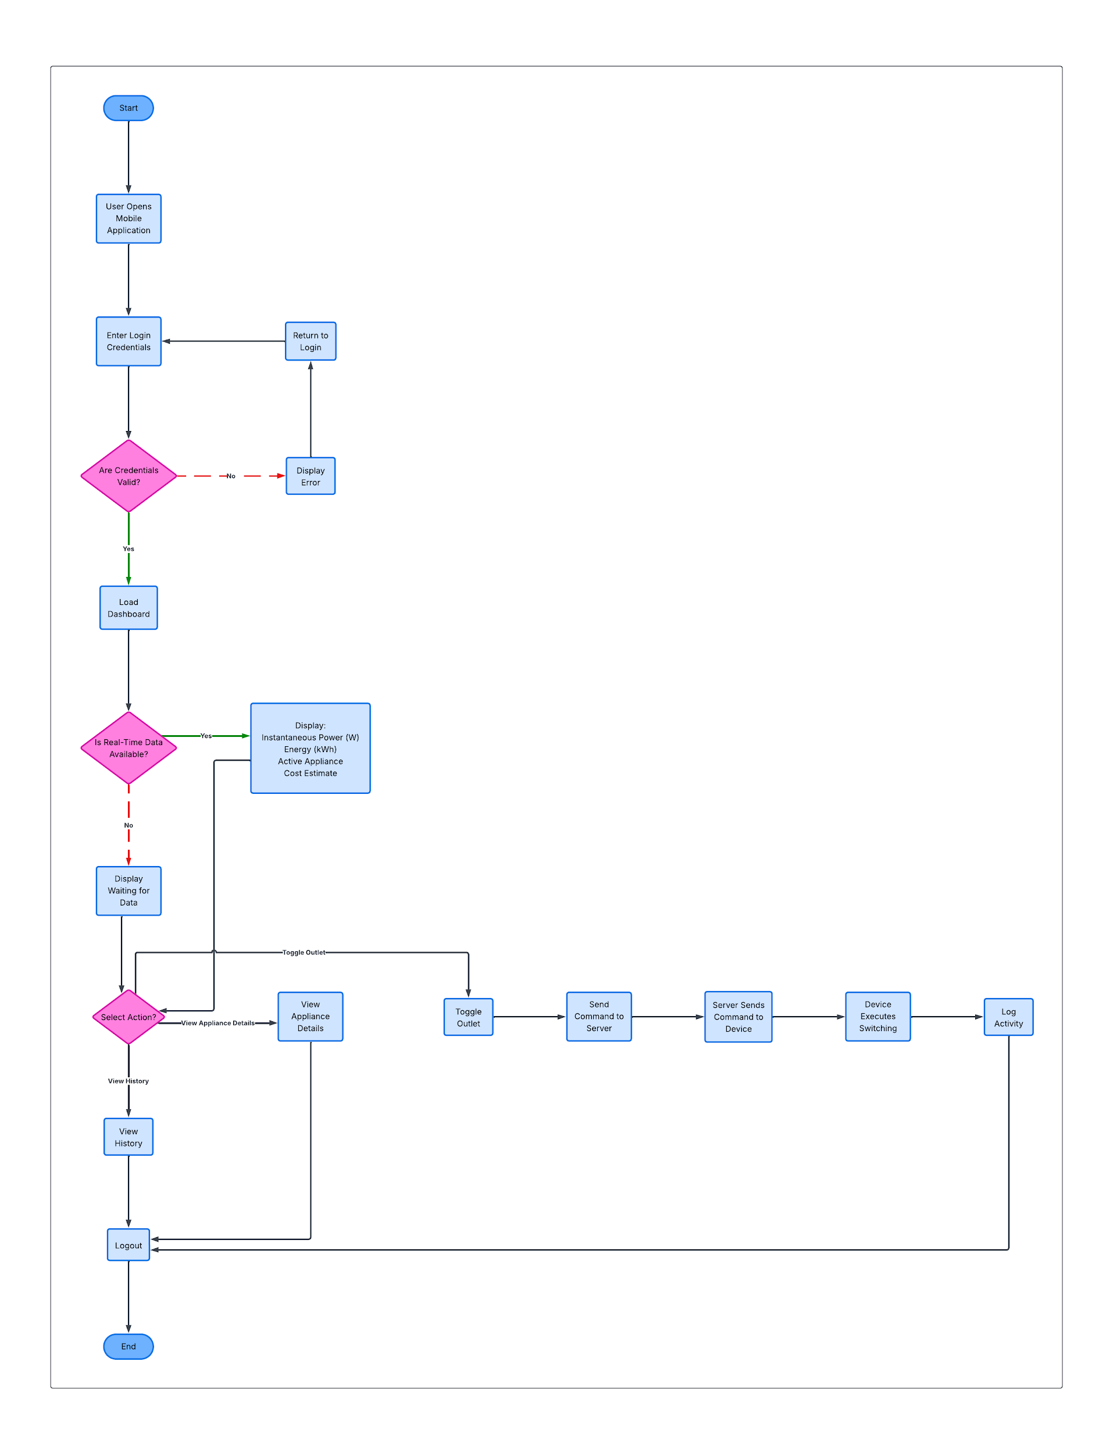
Appendix I: Proposed System Flowchart

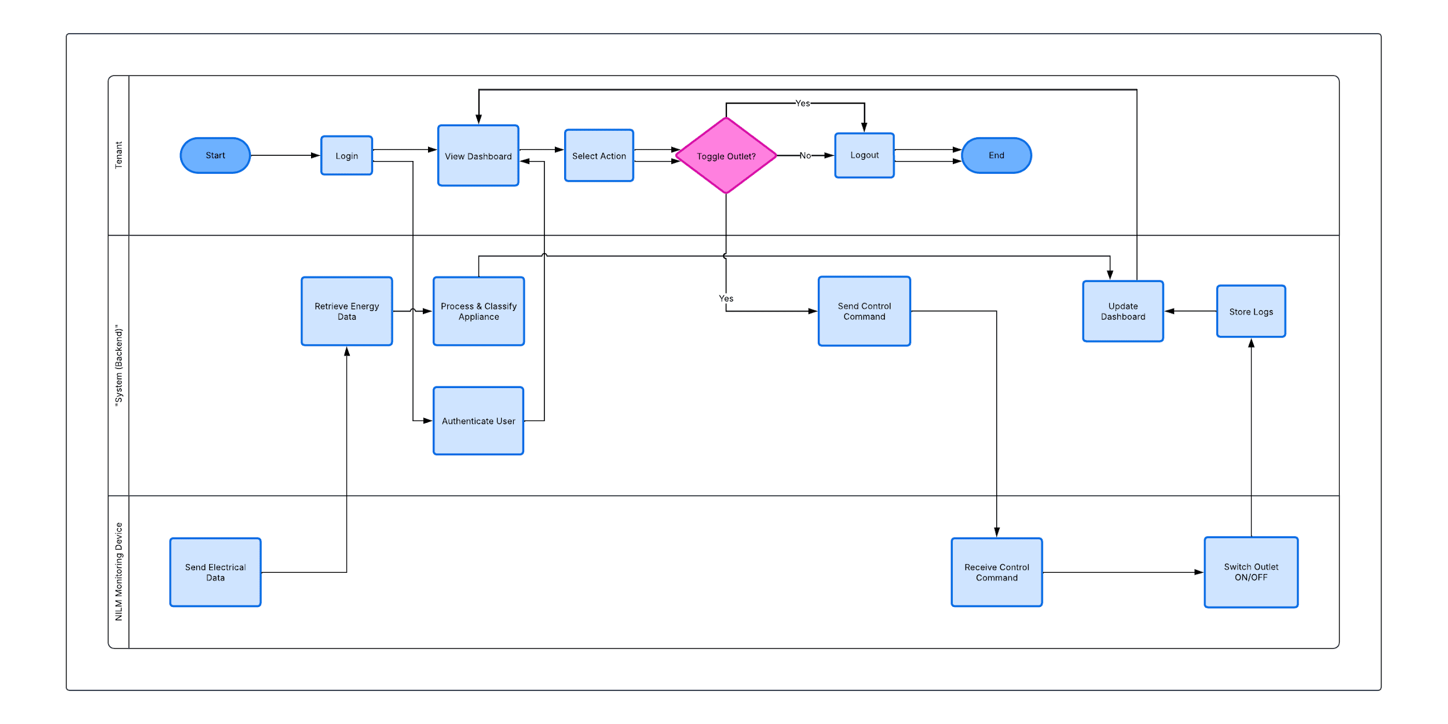
Appendix J: System Activity Diagram

Appendix K: Data Dictionary
Table: tblroles
Field Name | Data Type | Length | Key / Constraints | Description
role_id | INT | 11 | PK, AUTO_INCREMENT | Unique role identifier
role_name | VARCHAR | 50 | UNIQUE, NOT NULL | Name of user role

Table: tbluser_status
Field Name | Data Type | Length | Key / Constraints | Description
status_id | INT | 11 | PK, AUTO_INCREMENT | Unique status identifier
status_name | VARCHAR | 50 | UNIQUE, NOT NULL | Account status (active, inactive, suspended)

Table: tblusers
Field Name | Data Type | Length | Key / Constraints | Description
user_id | INT | 11 | PK, AUTO_INCREMENT | Unique user identifier
user_role_id | INT | 11 | FK → tblroles(role_id), NOT NULL | User role reference
user_status_id | INT | 11 | FK → tbluser_status(status_id), NOT NULL | User status reference
user_name | VARCHAR | 100 | NOT NULL | Full name of user
user_email | VARCHAR | 100 | UNIQUE, NOT NULL | Email address
user_password | VARCHAR | 255 | NOT NULL | Encrypted password
user_phone | VARCHAR | 20 | NULL | Contact number
created_at | DATETIME | — | DEFAULT CURRENT_TIMESTAMP | Account creation date

Table: tblappliance_categories
Field Name | Data Type | Length | Key / Constraints | Description
category_id | INT | 11 | PK, AUTO_INCREMENT | Appliance category ID
category_name | VARCHAR | 50 | UNIQUE, NOT NULL | Appliance category name

Table: tblappliance_types
Field Name | Data Type | Length | Key / Constraints | Description
appliance_type_id | INT | 11 | PK, AUTO_INCREMENT | Appliance type ID
appliance_type_category_id | INT | 11 | FK → tblappliance_categories(category_id), NOT NULL | Category reference
appliance_type_name | VARCHAR | 100 | NULL | Appliance name
appliance_type_typical_power_w | DECIMAL | 10,2 | NULL | Typical power (Watts)
appliance_type_power_factor | DECIMAL | 5,2 | NULL | Typical power factor
appliance_type_nominal_frequency_hz | DECIMAL | 5,2 | DEFAULT 60.00 | Nominal frequency (Hz)
appliance_type_frequency_tolerance | DECIMAL | 5,2 | DEFAULT 0.50 | Frequency tolerance
appliance_type_thd_reference | DECIMAL | 5,2 | NULL | Reference THD (%)
appliance_type_harmonic_signature | TEXT | — | NULL | Harmonic signature (JSON format)
appliance_type_power_pattern | ENUM | constant','cyclic','variable' | DEFAULT 'constant' | Power behavior pattern

Table: tbldevices
Field Name | Data Type | Length | Key / Constraints | Description
device_id | INT | 11 | PK, AUTO_INCREMENT | Device ID
device_name | VARCHAR | 100 | NULL | Device name
device_identifier | VARCHAR | 100 | UNIQUE | Unique device code
device_status | ENUM | online','offline' | DEFAULT 'online' | Device status
device_last_seen | DATETIME | — | NULL | Last communication timestamp
created_at | DATETIME | — | DEFAULT CURRENT_TIMESTAMP | Date registered

Table: tblrooms
Field Name | Data Type | Length / Values | Key / Constraints | Description
room_id | INT | 11 | PK, AUTO_INCREMENT | Room ID
room_name | VARCHAR | 100 | NULL | Room name
room_tenant_id | INT | 11 | FK → tblusers(user_id) | Assigned tenant
room_device_id | INT | 11 | FK → tbldevices(device_id) | Monitoring device reference
room_rate_per_kwh | DECIMAL | 10,2 | DEFAULT 12.00 | Electricity rate per kWh
room_status | ENUM | available','occupied' | DEFAULT 'occupied' | Occupancy status

Table: tblreading_headers
Field Name | Data Type | Length / Values | Key / Constraints | Description
reading_header_id | INT | 11 | PK, AUTO_INCREMENT | Reading session ID
reading_header_room_id | INT | 11 | FK → tblrooms(room_id) | Room reference
reading_header_device_id | INT | 11 | FK → tbldevices(device_id) | Device reference
reading_header_time | DATETIME | — | NULL | Reading timestamp

Table: tblreading_details
Field Name | Data Type | Length | Key / Constraints | Description
reading_detail_id | INT | 11 | PK, AUTO_INCREMENT | Reading detail ID
reading_detail_header_id | INT | 11 | FK → tblreading_headers(reading_header_id) | Header reference
reading_detail_voltage | DECIMAL | 10,2 | NULL | Voltage (V)
reading_detail_current | DECIMAL | 10,3 | NULL | Current (A)
reading_detail_power_w | DECIMAL | 10,2 | NULL | Power (Watts)
reading_detail_frequency | DECIMAL | 10,2 | NULL | Frequency (Hz)
reading_detail_power_factor | DECIMAL | 5,2 | NULL | Power factor
reading_detail_thd_percentage | DECIMAL | 5,2 | NULL | THD (%)
reading_detail_energy_kwh | DECIMAL | 10,4 | NULL | Energy consumption (kWh)

Table: tblappliance_detection_headers
Field Name | Data Type | Length | Key / Constraints | Description
detection_header_id | INT | 11 | PK, AUTO_INCREMENT | Detection session ID
detection_header_room_id | INT | 11 | FK → tblrooms(room_id) | Room reference
detection_header_reading_header_id | INT | 11 | FK → tblreading_headers(reading_header_id) | Reading reference
detection_header_time | DATETIME | — | NULL | Detection timestamp

Table: tblappliance_detection_details
Field Name | Data Type | Length / Values | Key / Constraints | Description
detection_detail_id | INT | 11 | PK, AUTO_INCREMENT | Detection detail ID
detection_detail_header_id | INT | 11 | FK → tblappliance_detection_headers(detection_header_id) | Header reference
detection_detail_appliance_type_id | INT | 11 | FK → tblappliance_types(appliance_type_id) | Appliance reference
detection_detail_status | ENUM | ON','OFF' | NULL | Appliance state
detection_detail_confidence | DECIMAL | 5,2 | NULL | Confidence score
detection_detail_detected_power | DECIMAL | 10,2 | NULL | Detected power
detection_detail_detected_frequency | DECIMAL | 10,2 | NULL | Detected frequency
detection_detail_detected_thd | DECIMAL | 5,2 | NULL | Detected THD

Table: tblbilling_headers
Field Name | Data Type | Length / Values | Key / Constraints | Description
billing_header_id | INT | 11 | PK, AUTO_INCREMENT | Billing ID
billing_header_room_id | INT | 11 | FK → tblrooms(room_id) | Room reference
billing_header_tenant_id | INT | 11 | FK → tblusers(user_id) | Tenant reference
billing_header_month | VARCHAR | 7 | NULL | Billing month (YYYY-MM)
billing_header_total_kwh | DECIMAL | 10,2 | NULL | Total kWh consumed
billing_header_total_amount | DECIMAL | 10,2 | NULL | Total billing amount
billing_header_status | ENUM | pending','paid' | DEFAULT 'pending' | Payment status

Table: tblbilling_details
Field Name | Data Type | Length / Values | Key / Constraints | Description
billing_detail_id | INT | 11 | PK, AUTO_INCREMENT | Billing detail ID
billing_detail_header_id | INT | 11 | FK → tblbilling_headers(billing_header_id) | Header reference
billing_detail_rate_per_kwh | DECIMAL | 10,2 | NULL | Electricity rate
billing_detail_energy_charge | DECIMAL | 10,2 | NULL | Energy charge amount

Table: tblappliance_usage_summary
Field Name | Data Type | Length / Values | Key / Constraints | Description
summary_id | INT | 11 | PK, AUTO_INCREMENT | Summary ID
summary_billing_header_id | INT | 11 | FK → tblbilling_headers(billing_header_id) | Billing reference
summary_appliance_type_id | INT | 11 | FK → tblappliance_types(appliance_type_id) | Appliance reference
summary_runtime_hours | DECIMAL | 10,2 | NULL | Runtime hours
summary_energy_kwh | DECIMAL | 10,2 | NULL | Energy consumed
summary_cost | DECIMAL | 10,2 | NULL | Computed cost

Table: tblalerts
Field Name | Data Type | Length / Values | Key / Constraints | Description
alert_id | INT | 11 | PK, AUTO_INCREMENT | Alert ID
alert_room_id | INT | 11 | FK → tblrooms(room_id) | Room reference
alert_type | VARCHAR | 50 | NULL | Alert type
alert_message | TEXT | — | NULL | Alert message
alert_status | ENUM | new','resolved' | DEFAULT 'new' | Alert status
created_at | DATETIME | — | DEFAULT CURRENT_TIMESTAMP | Creation timestamp

Table: tblrelay_control_logs
Field Name | Data Type | Length / Values | Key / Constraints | Description
log_id | INT | 11 | PK, AUTO_INCREMENT | Log ID
relay_control_log_room_id | INT | 11 | FK → tblrooms(room_id) | Room reference
relay_control_log_command | ENUM | ON','OFF' | NULL | Relay command
executed_at | DATETIME | — | DEFAULT CURRENT_TIMESTAMP | Execution time

Table: tblsystem_settings
Field Name | Data Type | Length / Values | Key / Constraints | Description
setting_id | INT | 11 | PK, AUTO_INCREMENT | Setting ID
setting_key | VARCHAR | 100 | UNIQUE, NOT NULL | Setting key
setting_value | TEXT | — | NULL | Setting value
setting_description | VARCHAR | 255 | NULL | Setting description
setting_category | ENUM | billing','detection','alerts','general' | DEFAULT 'general' | Setting category
setting_updated_by | INT | 11 | FK → tblusers(user_id) | Updated by
updated_at | DATETIME | — | ON UPDATE CURRENT_TIMESTAMP | Last update time

Table: tblsystem_logs
Field Name | Data Type | Length / Values | Key / Constraints | Description
log_id | INT | 11 | PK, AUTO_INCREMENT | Log ID
system_log_user_id | INT | 11 | FK → tblusers(user_id) | User reference
system_log_action | VARCHAR | 255 | NULL | Action performed
created_at | DATETIME | — | DEFAULT CURRENT_TIMESTAMP | Timestamp

Appendix L: UI/UX
POV TENANTS
DASHBOAD


Appliances
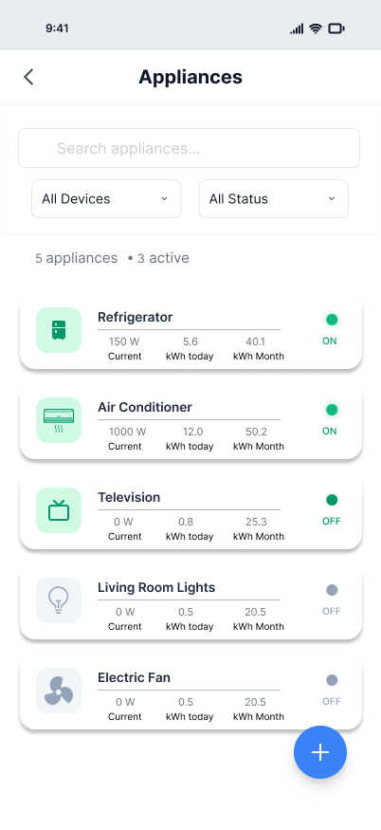

Reports
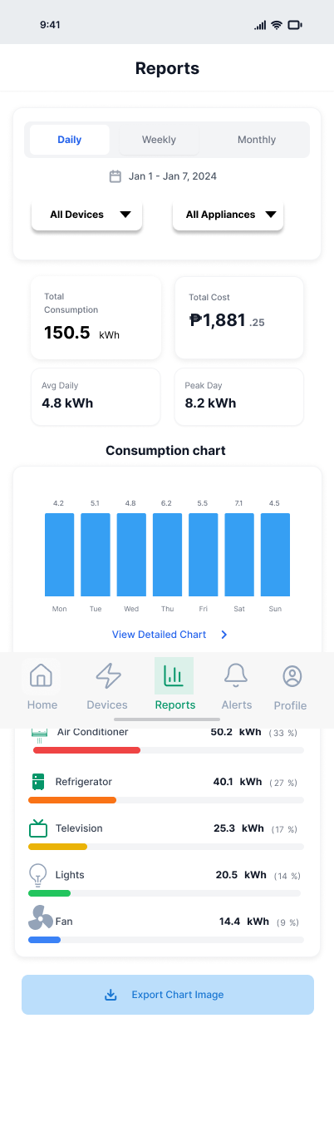

POV Landlord
Dashboard


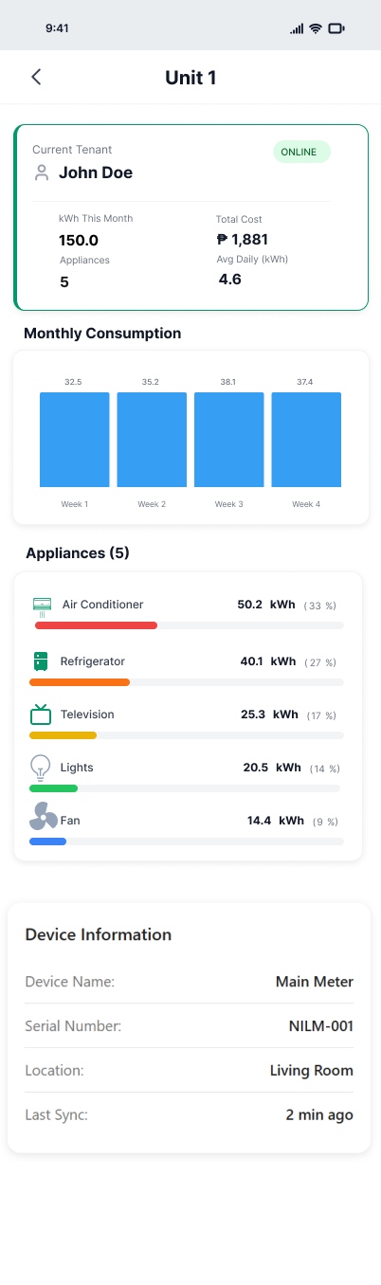

Appendix M: Code Snippets

Appendix N: Detailed SUS Test

Appendix O: Functional and Non-Functional Requirements

